# Statistics Report:

Performance of Email Campaign Classified by Subject Type

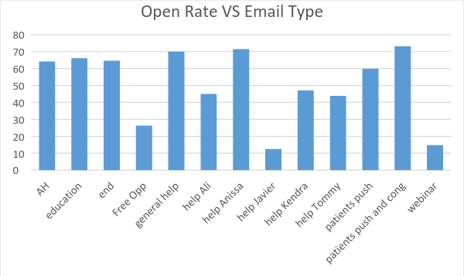

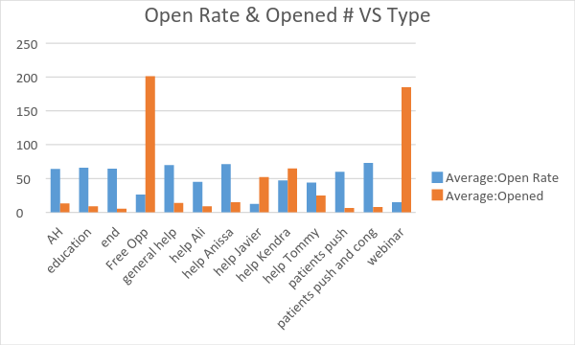

In general, the more emails sent in each email campaign, the less the open rate is. So we need to take this factor into consideration when evaluating the performance of the emails.

There’s some email that push patients and congratulate them and some just push patient (final push friday)

* Emails that sent to friends and family

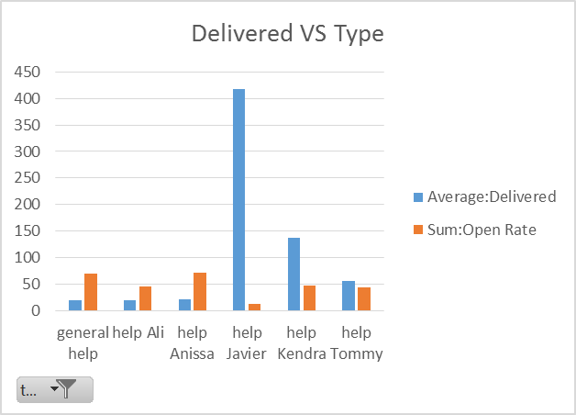

The email titled “Please Help Your Friend Raise Needed Funds” (general help) and the email helping Anissa are the more efficient than that helping Ali. **Kendra**’s email is more efficient than Javier’s, and even all other emails in this category considering its large number of email delivered.

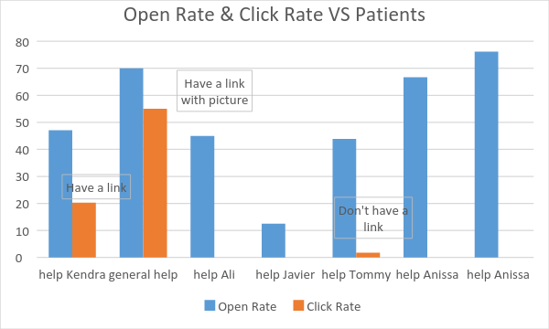

More recipients that opened the email of general help click into the link than those for the email helping Kendra. The nature of the email as well as the link format (picture) might be the reason.

* Emails that related to training and webinar

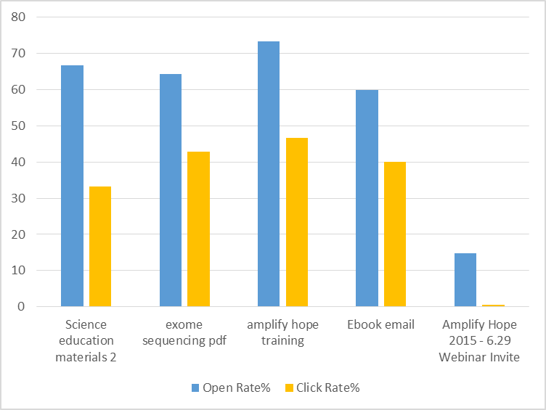

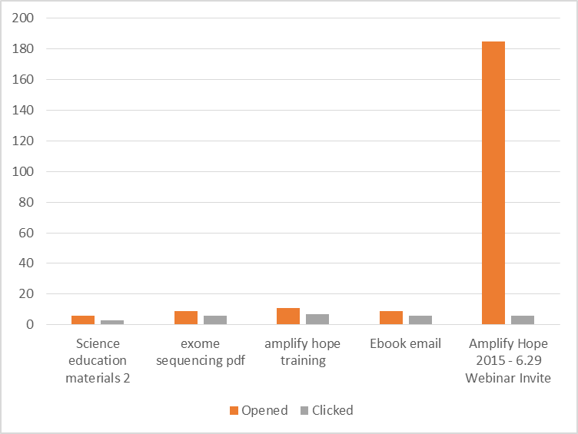

The **webinar** email has the least conversion rate (click/open). **Science education materials 2** is the second least popular one with 50% click/open rate although it has the second highest open rate.

Engagement of the Patients and Number of their Donors

**Campaign**    **Shares Number of donors** **Total donations Platforms**     **Date**

Anissa           49 25         2076    YouCaring 10/15

Tommy       43    6    275    YouCaring

**Ali                  1.5K 47        5844                 YouCaring**

**Charlie            486 11T 74        5700       CrowdRise 6 teams**

Angela            67 F 14T 3        200         CrowdRise

Fedor             89F 19T          6    870        CrowdRise 2 teams

Javier            72     2   150 Indiegogo Life

Kendra        76     37    2825 Indiegogo Life

Ria     55 8         460    Indiegogo Life

|  |  |  |  |  |  |  |  |  |  |  |
| --- | --- | --- | --- | --- | --- | --- | --- | --- | --- | --- |
|  | Email | AH training | Ebook | Science education | Help sent | Help delivered | Help opened | shares | # of doners | $ Amount |
| Anissa | speechpaths@yahoo.com | 0 | 2 | 2 | 21 | 21 | 16 | 49 | 25 | 2076 |
| Tommy | Not found | - | - |  | 66 | 57 | 25 | 43 | 6 | 275 |
| Ali | [hmed306@umn.edu](mailto:hmed306@umn.edu) ?/ [alleenaali@yahoo.com](mailto:alleenaali@yahoo.com) ? | Not sent | Not sent | Not sent | 20 | 20 | 9 | 1500 | 47 | 5844 |
| Charlie | [nikki.tait@yahoo.com](mailto:nikki.tait@yahoo.com)  ?? | 2 | 1 | 2 | None | none | None | 486+11=  497 | 74 | 5700 |
| Angela | angela@ strydersstory.com | 2 | 2 | 0 | None | None | None | 67+14=  81 | 3 | 200 |
| Fedor | fedor.gavrilov@gmail.com | 2 | 2 | 2 | None | None | None | 89+19=  108 | 6 | 870 |
| Javier | javier_rodarte@hotmail.com | 2 | 2 | 1 | 589 | 417 | 52 | 72 | 2 | 150 |
| Kendra | kendraz@centurytel.net | Hard bounce | Hard bounce | Hard bounce | 168 | 138 | 65 | 76 | 37 | 2825 |
| Ria | Not found | - | - | - | None | none | none | 55 | 8 | 460 |

In training:

Delivered but not opened---0

Opened but not clicked—1

Clicked—2

The comparisons below may give us some information. Generally speaking, there’s no single action that guarantees a higher amount of fund raised.

Engagement in training? Kendra VS Fedor

Email sent to friends and families? Charlie VS Kendra and Javier, Kendra VS Javier

Shares? Ali VS Charlie, Anissa VS Kendra

Of course, there’s a lot of things that can’t be reflected by data, like the content of their campaign pages, email itself—have a link or not?

When Do People Give Money

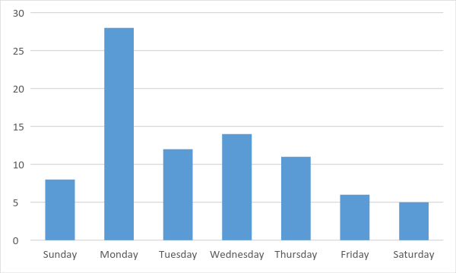

When the Emails Are Sent

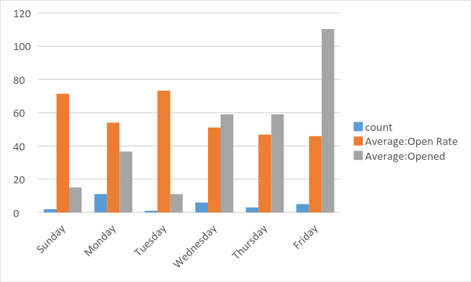

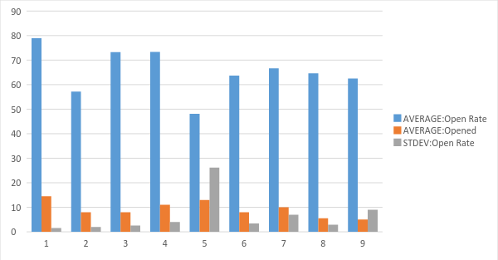

We can’t say which day has large open rate than others, because the data size is too small so that we cannot control other factors.